Truncated Octahedron
# Source: AI Source: Provided by: [Data Path: Persons Table -> ID Column: 1, Name_En Column: Motasem Essam] -> From: [ChatGPT] on [7/25/2026]
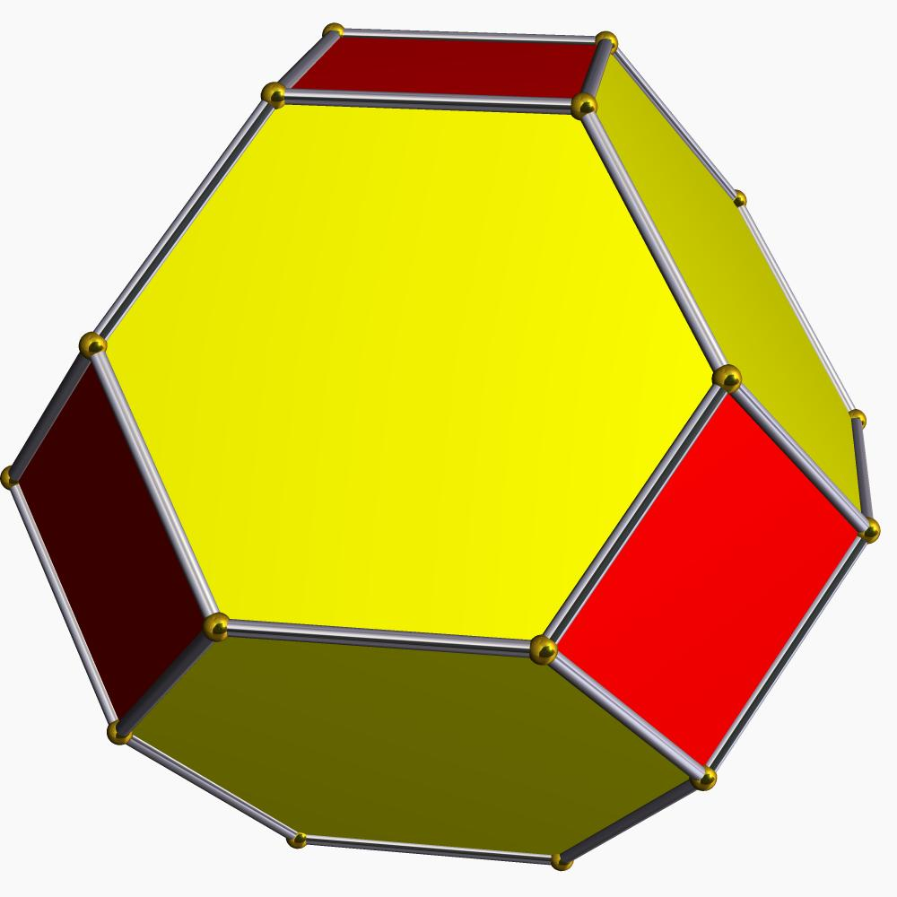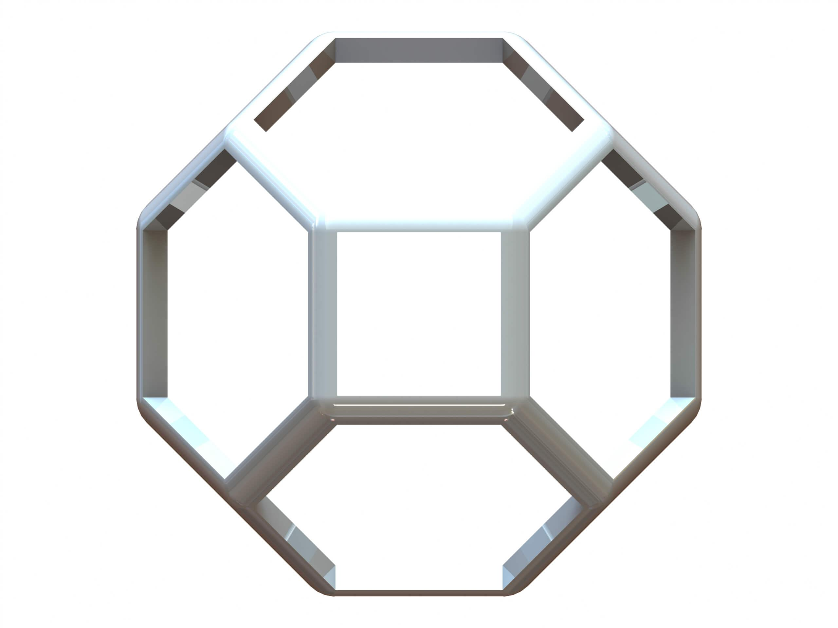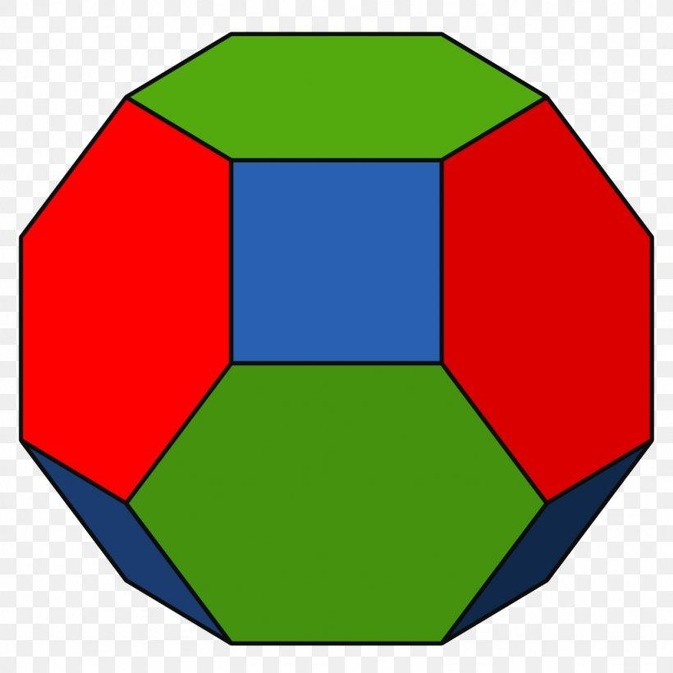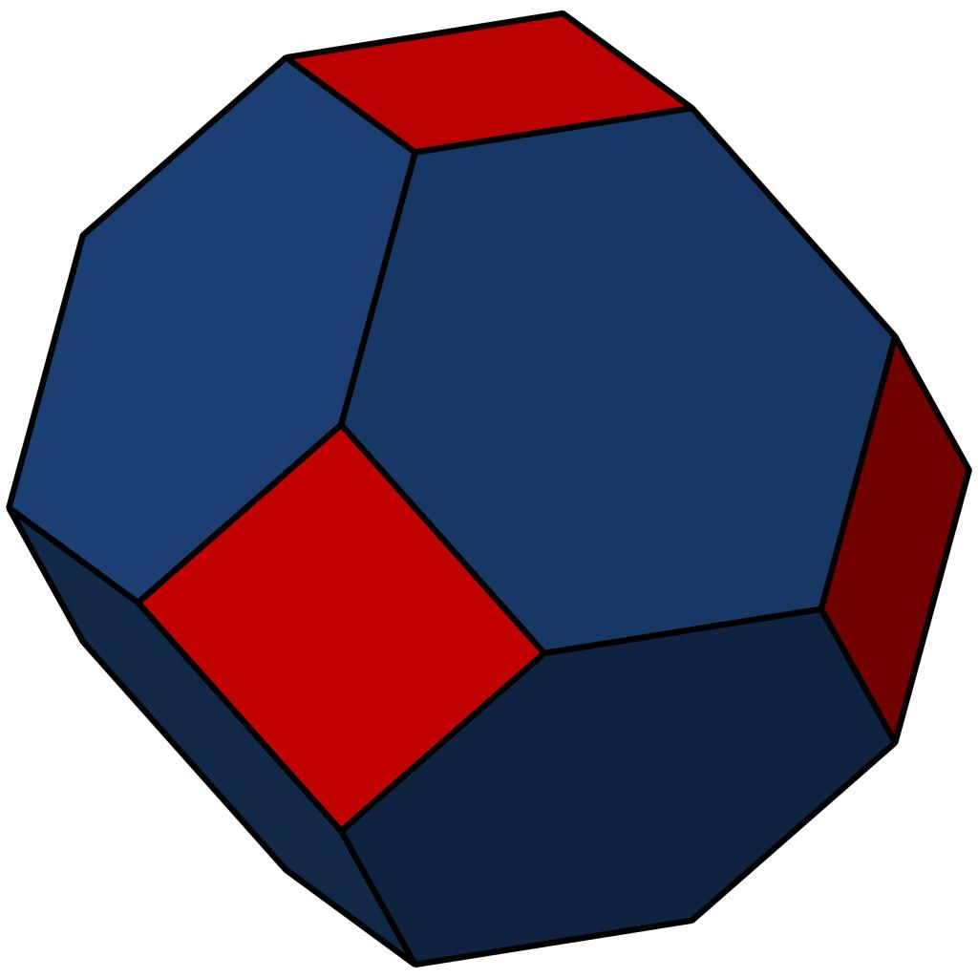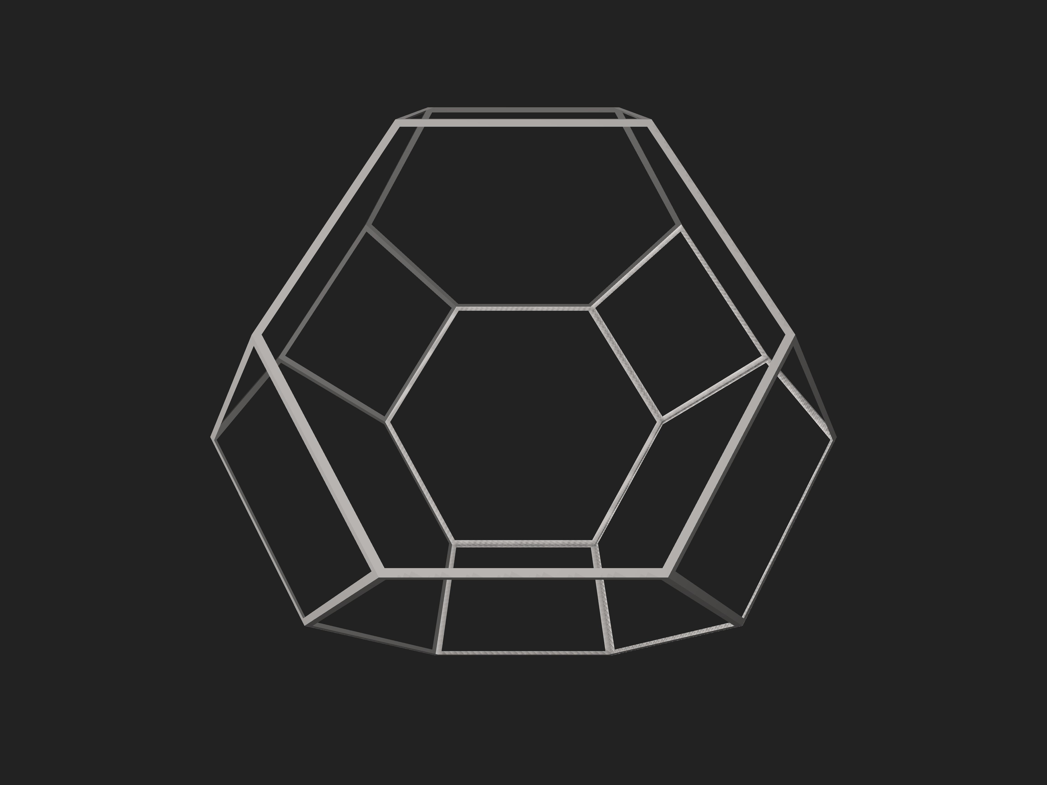

Definition
# Source: AI Source: Provided by: [Data Path: Persons Table -> ID Column: 1, Name_En Column: Motasem Essam] -> From: [ChatGPT] on [7/25/2026]
A Truncated Octahedron is a three-dimensional polyhedron formed by cutting off the six vertices of an original octahedron using planes.
The truncation process creates new square faces while modifying the original triangular faces into hexagons.

Geometric Characteristics
# Source: AI Source: Provided by: [Data Path: Persons Table -> ID Column: 1, Name_En Column: Motasem Essam] -> From: [ChatGPT] on [7/25/2026]
- Original Solid: Octahedron
- Original Vertices: 6
- New Faces: 6 squares and 8 hexagons.
- Total Faces: 14
- Total Edges: 36
- Total Vertices: 24

Face Structure
# Source: AI Source: Provided by: [Data Path: Persons Table -> ID Column: 1, Name_En Column: Motasem Essam] -> From: [ChatGPT] on [7/25/2026]
The truncated octahedron consists of:
- 6 Square Faces: Created by cutting off the six original vertices.
- 8 Hexagonal Faces: Obtained by modifying the eight original triangular faces of the octahedron.

Mathematical Properties
# Source: AI Source: Provided by: [Data Path: Persons Table -> ID Column: 1, Name_En Column: Motasem Essam] -> From: [ChatGPT] on [7/25/2026]
Let:
- $F$ = Number of faces
- $E$ = Number of edges
- $V$ = Number of vertices

Number of Faces
# Source: AI Source: Provided by: [Data Path: Persons Table -> ID Column: 1, Name_En Column: Motasem Essam] -> From: [ChatGPT] on [7/25/2026]
$$F=6+8=\boxed{14}$$

Number of Edges
# Source: AI Source: Provided by: [Data Path: Persons Table -> ID Column: 1, Name_En Column: Motasem Essam] -> From: [ChatGPT] on [7/25/2026]
$$E=\boxed{36}$$

Number of Vertices
# Source: AI Source: Provided by: [Data Path: Persons Table -> ID Column: 1, Name_En Column: Motasem Essam] -> From: [ChatGPT] on [7/25/2026]
$$V=\boxed{24}$$

Euler's Formula
# Source: AI Source: Provided by: [Data Path: Persons Table -> ID Column: 1, Name_En Column: Motasem Essam] -> From: [ChatGPT] on [7/25/2026]
For a convex polyhedron:
$$V-E+F=2$$
Substituting:
$$24-36+14=2$$
$$\boxed{2=2}$$
Therefore, the truncated octahedron satisfies Euler's formula.

Constructing Truncated Octahedron in Solid Geometry

Instruments Used
# Source: AI Source: Provided by: [Data Path: Persons Table -> ID Column: 1, Name_En Column: Motasem Essam] -> From: [ChatGPT] on [7/25/2026]
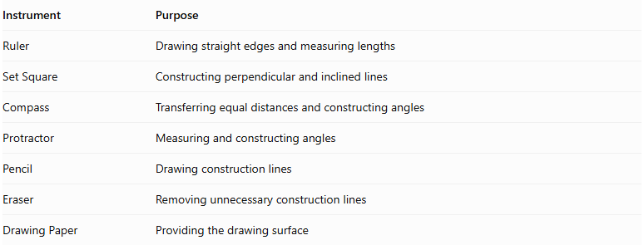
Instrument | Purpose
Ruler | Drawing straight edges and measuring lengths
Set Square | Constructing perpendicular and inclined lines
Compass | Transferring equal distances and constructing angles
Protractor | Measuring and constructing angles
Pencil | Drawing construction lines
Eraser | Removing unnecessary construction lines
Drawing Paper | Providing the drawing surface

Construction Procedures

A. Original Octahedron-Based Construction
# Source: AI Source: Provided by: [Data Path: Persons Table -> ID Column: 1, Name_En Column: Motasem Essam] -> From: [ChatGPT] on [7/25/2026]
This method starts with a regular octahedron and transforms it into a truncated octahedron.
- Draw a regular octahedron using an appropriate pictorial representation.
- Identify its six vertices.
- Mark equal truncation distances along the four edges meeting at each vertex.
- Construct a square cutting boundary around each original vertex by connecting the marked points.
- Repeat the procedure at all six vertices.
- Remove or visually suppress the original corner regions.
- Identify the eight remaining hexagonal faces.
- Darken the visible edges and distinguish hidden edges.
- Check that the resulting model contains 6 square faces and 8 hexagonal faces.

B. Edge-Based Construction
# Source: AI Source: Provided by: [Data Path: Persons Table -> ID Column: 1, Name_En Column: Motasem Essam] -> From: [ChatGPT] on [7/25/2026]
- Draw the original regular octahedron.
- Mark equal truncation distances along its twelve edges.
- Each original edge receives two truncation marks, one near each endpoint.
- Connect the appropriate marks around each original vertex to create six square faces.
- Connect the remaining points on the original triangular faces to form eight hexagonal faces.
- Refine the final solid representation.

C. Face-Based Construction
# Source: AI Source: Provided by: [Data Path: Persons Table -> ID Column: 1, Name_En Column: Motasem Essam] -> From: [ChatGPT] on [7/25/2026]
- Draw the eight triangular faces of the original octahedron.
- Mark truncation points along the three edges of each triangular face.
- Connect the marked points to form a hexagonal boundary inside each original triangular face.
- Construct the six square faces between adjacent hexagonal faces.
- Join the face boundaries into one continuous polyhedron.

D. Net-Based Construction
# Source: AI Source: Provided by: [Data Path: Persons Table -> ID Column: 1, Name_En Column: Motasem Essam] -> From: [ChatGPT] on [7/25/2026]
- Draw a net containing eight regular hexagons and six squares.
- Arrange the faces so that their shared edges correspond correctly.
- Add tabs if the net will be used for physical assembly.
- Cut out the net.
- Fold along the shared edges.
- Join the corresponding edges to form the truncated octahedron.
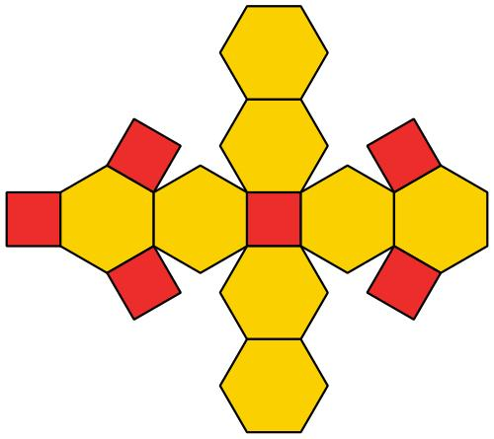

Key Points
# Source: AI Source: Provided by: [Data Path: Persons Table -> ID Column: 1, Name_En Column: Motasem Essam] -> From: [ChatGPT] on [7/25/2026]
- It is formed by truncating the six vertices of an octahedron.
- It has 6 square faces and 8 hexagonal faces.
- It has 14 faces, 36 edges, and 24 vertices.
- Each original vertex produces one new square face.
- Each original triangular face becomes a hexagonal face.
- It is an Archimedean solid when uniformly truncated.

Conclusion
# Source: AI Source: Provided by: [Data Path: Persons Table -> ID Column: 1, Name_En Column: Motasem Essam] -> From: [ChatGPT] on [7/25/2026]
The truncated octahedron is a three-dimensional geometric solid obtained by cutting off the six vertices of a regular octahedron. It consists of six squares and eight regular hexagons, creating a symmetrical solid with 14 faces, 36 edges, and 24 vertices.

